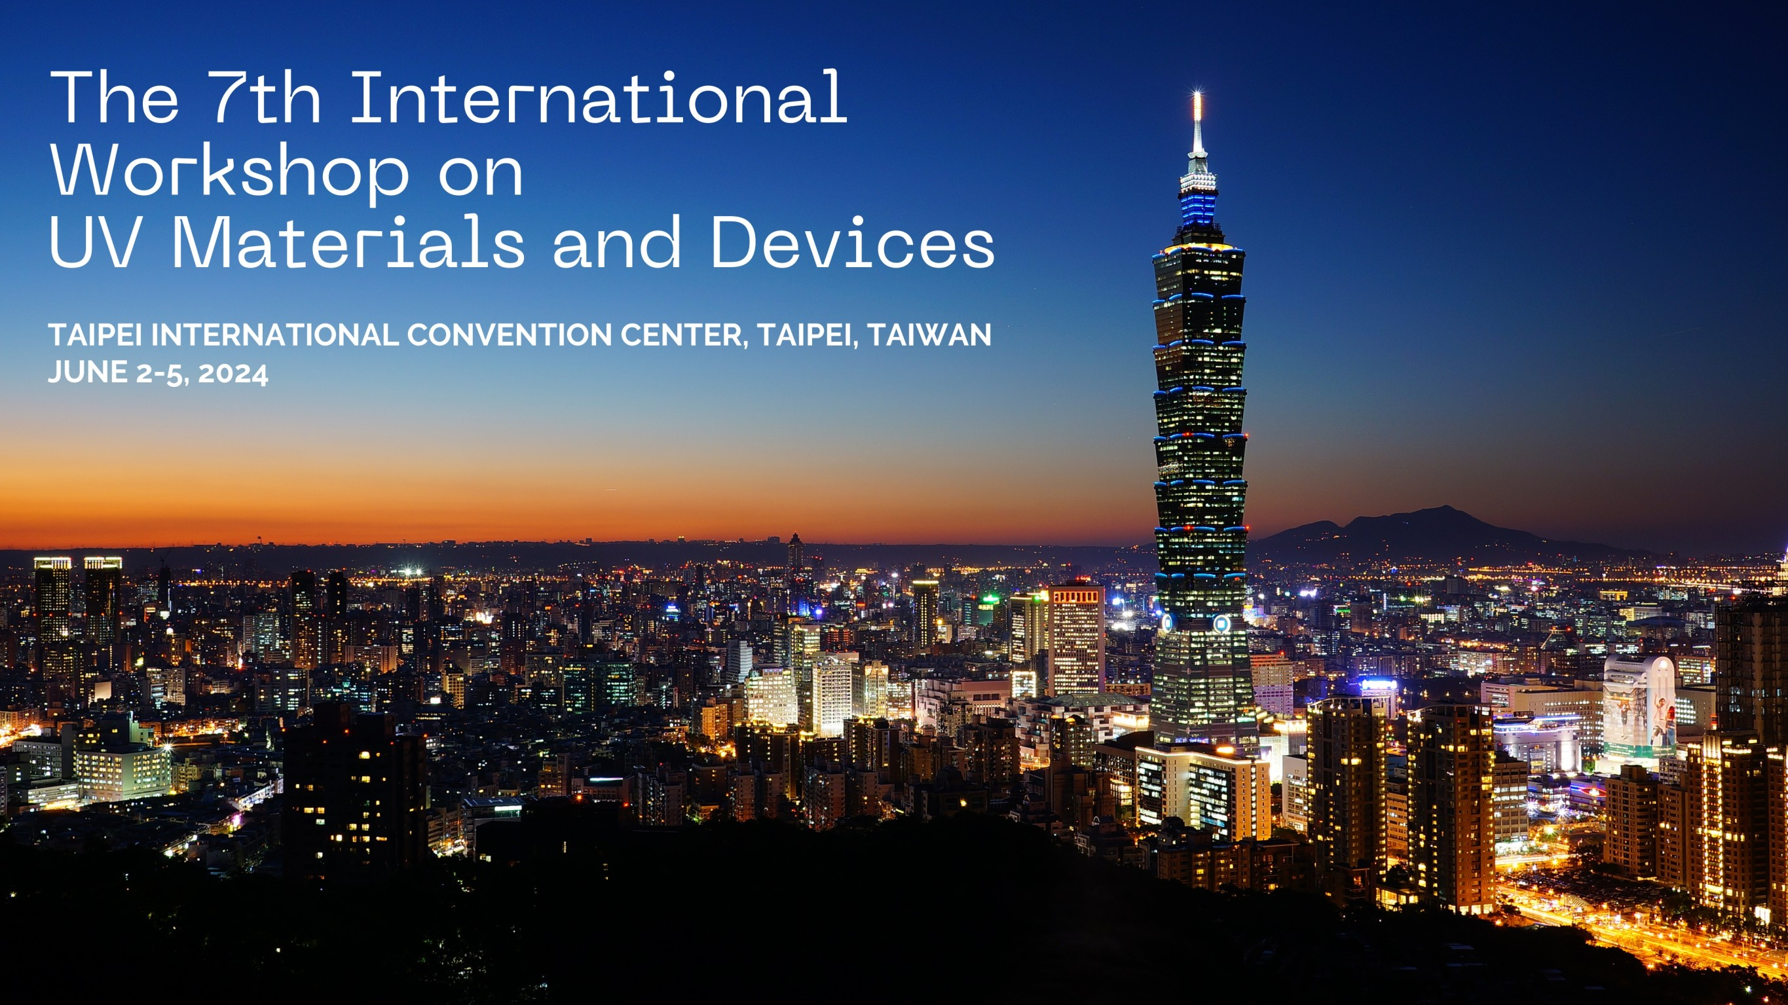
EXHIBITION AND SPONSORSHIP APPLICATION
Organizers
This conference is organized by National Yang Ming Chiao Tung University and Taiwan Vacuum Society.

Exhibition Dates
09:00 on June 3 (Mon.) – 17:00 on June 5 (Wed.), 2024.

About IWUMD 2024
The seventh International Workshop on UV Materials and Devices (IWUMD 2024) will be held held on June 2-5, 2024 November 13 - 18, 2024 at Taipei International Convention Center (TICC), Taipei, Taiwan. IWUMD 2024 follows a series of successful meetings last held in Beijing, China (IWUMD 2016), Fukuoka, Japan (IWUMD 2017), Kunming, China (IWUMD 2018), Saint Petersburg, Russia (IWUMD 2019), Jeju, Korea (IWUMD 2022), and Metz, France (IWUMD 2023). The workshop presents high-level scientific and technological advances in UV materials and devices and featured plenary sessions, parallel topical sessions, poster sessions and an industrial exhibition.

Exhibitions
- Exhibition Site
Taipei International Convention Center (TICC), Taipei, Taiwan

- Exhibition Booth
- Booth space: 3m (wide) × 2m (deep) × 2.5 m (high)
- One table (180 cm × 60 cm) and two chairs
- Electric power: 110V, 2 sockets
- Two registration badges, including the banquet per booth
- Advertisements: IWUMD 2024 web page
- Fee:
Booth Exhibition | Fee (Tax included)
Regular | NTD $80,000
- Booth booking will be cancelled if the payment is not made by the due date (one week after receiving the notification email).
- Exhibitors will be notified about the date for the selection of booth locations.
- The organizer reserves the right to refuse any unsuitable booth booking.

Sponsorship
Advertisement on APWS2022 Proceedings and Conference Bags
Type | Description | Fee (Tax included)
Logo on Conf. bags | Full side | NTD $50,000 (One AD only)
 | Half of one side | NTD $30,000 (One AD only)
Coffee Breaks | 3-day (June 3-5, am & pm) | NTD $45,000
Banners | Ceiling Banner (天花板懸吊布條) | NTD $10,000/each
Proceedings | Front cover (inner side, color) | NTD $45,000 (One AD only)
Proceedings | Back cover (outer side, color) | NTD $45,000 (One AD only)
Proceedings | Back cover (inner side, color) | NTD $30,000 (One AD only)
Proceedings | Inner page (full A4, color) | NTD $15,000
Proceedings | Inner page (full A4, B/W printing) | NTD $10,000
Proceedings | Inner page (half A4, color) | NTD $8,000
Proceedings | Inner page (half A4, B/W printing) | NTD $5,000

Register Your Interest to Sponsor or Exhibit at IWUMD 2024
Please return the Exhibition and Sponsorship form before April 30, 2024 to secretary@iwumd2024.org.tw (Prof. Kun-Yu Lai). A notification letter will be sent out once the request has been processed.
Payment
The exhibition/sponsorship fee is expected to pay in full within one week after receiving the notification email.
- Pay in NTD
匯款戶名：台灣真空學會
銀行：兆豐國際商業銀行 (銀行代號：017) 分行：竹科新安分行(分行代碼0206)
帳號：020-09107351。

- Pay in USD
Remittance Account Name: TAIWAN VACUUM SOCIETY
Account Number: 020-09107351
Bank SWIFT/BIC number (for wire transfer): ICBCTWTP020
Bank Name: MEGA INTERNATIONAL COMMERCIAL BANK
Branch: HSINCHU SCIENCE PARK HSIN-AN
Address: No.1, Xin’an Rd., East Dist., Hsinchu City 300
Country: TAIWAN

- Please email the payment confirmation form (see below) to secretary@iwumd2024.org.tw within two days after the payment has been made. A confirmation email will be sent to the exhibitor/sponsor to confirm the completion of crediting the payment.

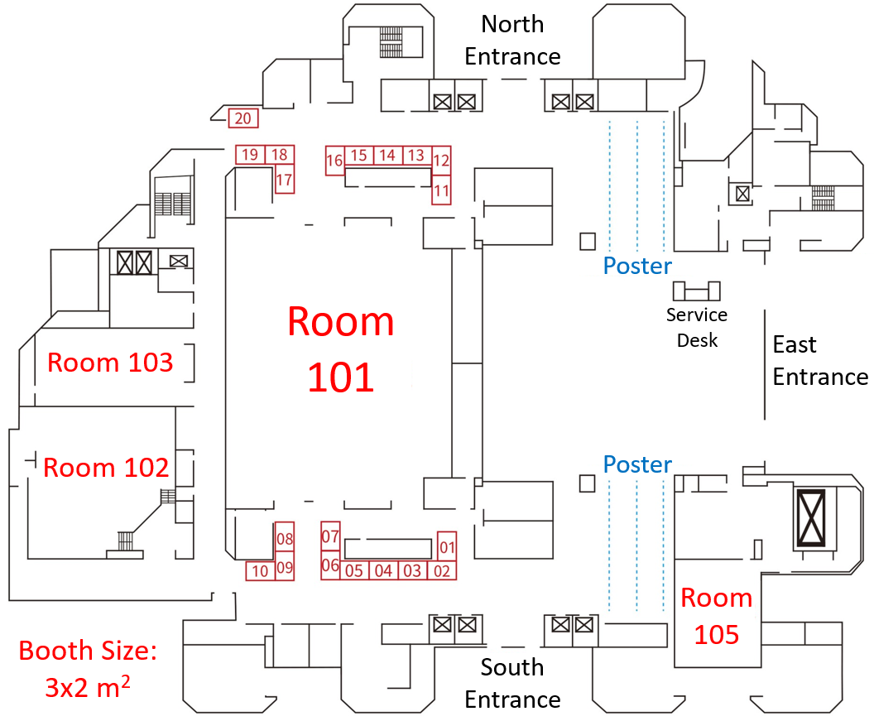
IWUMD 2024 Exhibition and Sponsorship Form
No. | (by IWUMD2024) | Company name (English)
GUI number |  | Company name (Chinese)
Tel |  | URL:
Fax |  | Company address
Mailing address | □ Same as the company address  □
Event manager | Name | Dept./Title | Tel/Ext | Mobile |  |  | E-mail
Person of contact | Name | Dept./Title | Tel/Ext | Mobile |  |  | E-mail
Exhibition/Sponsorship
□ Booth Location:
□ Advertisement on IWUMD 2024 Proceedings/Website

Total exhibition/Sponsorship fee: (written by IWUMD 2024) |  |  |  |  |  | Reviewer

Person of application (Signature): Date:

IWUMD 2024 Exhibition/Sponsorship Payment Confirmation Form
Company Name |  | Title of Return Receipt
GUI number |  | Mailing Address
Contact Person of the Payment |  | Contact Person’s TEL
Name of the Remitter |  | Contact Person’s Email Address
Amount of Remittance |  | Time of Remittance
Paste the copy/image of the remittance slip or check here

Contact Us
If you have any question, please feel free to contact us at
 | Person | TEL | E-mail
NCU | Prof. Kun-Yu Lai  (賴昆佑) | +886-3-422-7151 ext: 25256 | secretary@iwumd2024.org.tw

